The Society of Anaesthetists

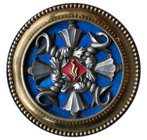

of the South Western Region

The Annual General Meeting of the Society will be held at the Autumn Meeting in Bristol 22 November 2019

Hon. Secretary

--------------------------------------------------------------------------------------------------------------

A G E N D A

19.01 Apologies for Absence

19.02 President’s Remarks

19.03 Minutes of AGM from 6 December 2019

19.04 Hon Secretary’s Report

19.05 Hon Treasurer’s Report

19.06 Report from the Editor of Anaesthesia Points West

19.07 Prizes and Awards:

- President’s Prize to be awarded by Mike Kinsella
- SASWR Intersurgical Prize
- New travelling bursary

19.08 SWARM and STAR update

19.09 Future Meetings

- Truro May 20/21 2020
- Exeter autumn 2020

19.10 announcement of new SASWR president

19.11 Any other competent business
- Changes to constitution
- Changes to reimbursement policy

19.12 Date of next AGM

19.13 Installation of new President

Hon Secretary

